CURNEU

SOLVING THE PROBLEM FOR THE SET :SD03QO16

DATASET OF MALARIA :

IMPORTING THE LIBRARIES AND VISUALIZATION OF DATA :

1. VISUALIZATION OF ESTIMATED_NUMBERS DATASET :

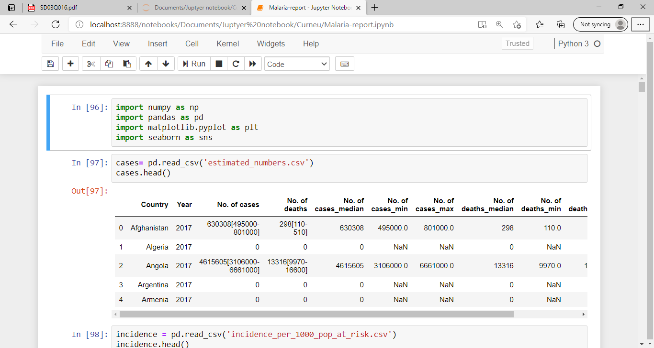

1. VISUALIZATION OF INCIDENCE_OF_1000_POP_AT_RISK AND REPORTED_NUMBERS DATASET :

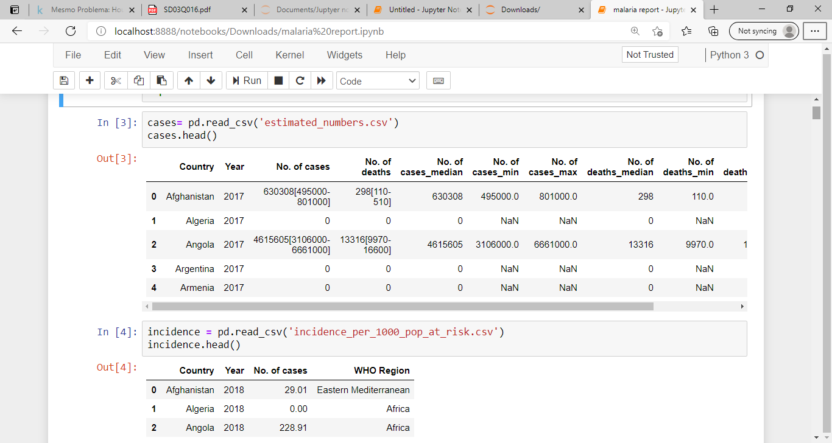

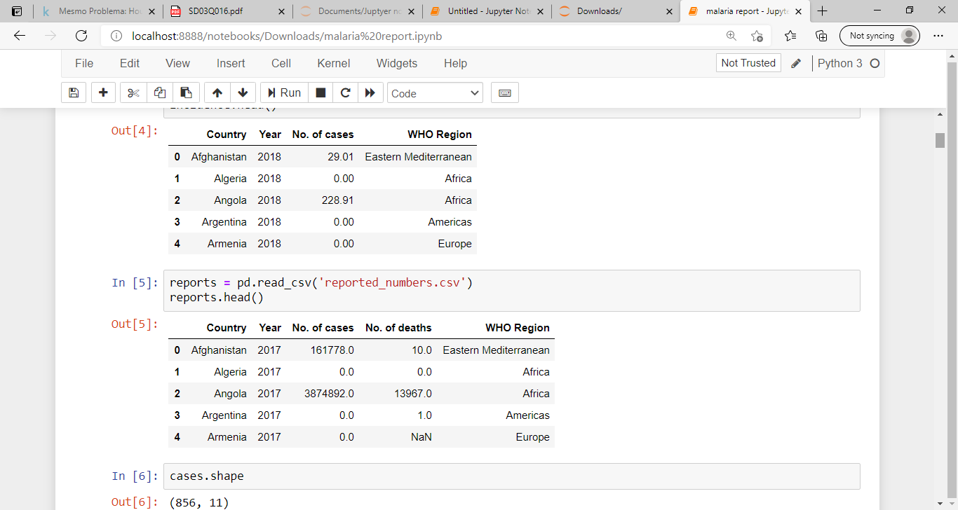

REPORT :

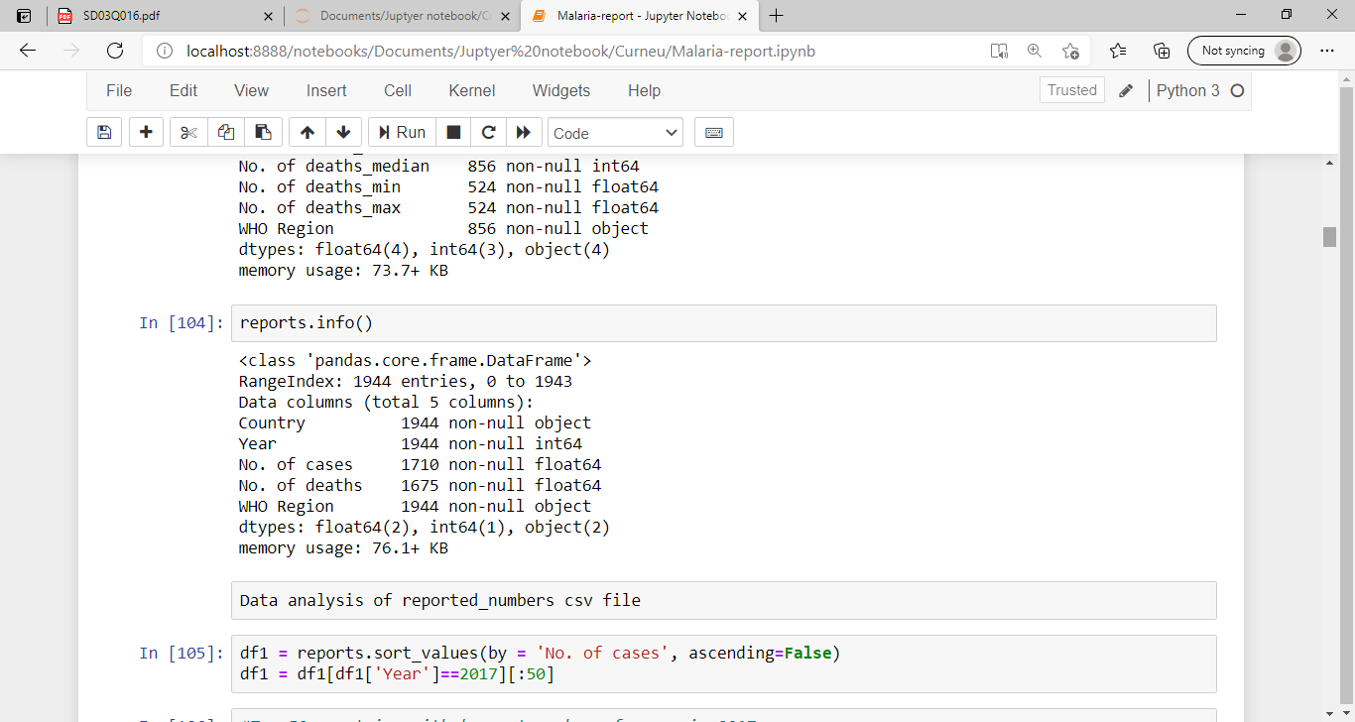

VISUALIZATION OF NUMBER OF CASES IN 2016 :

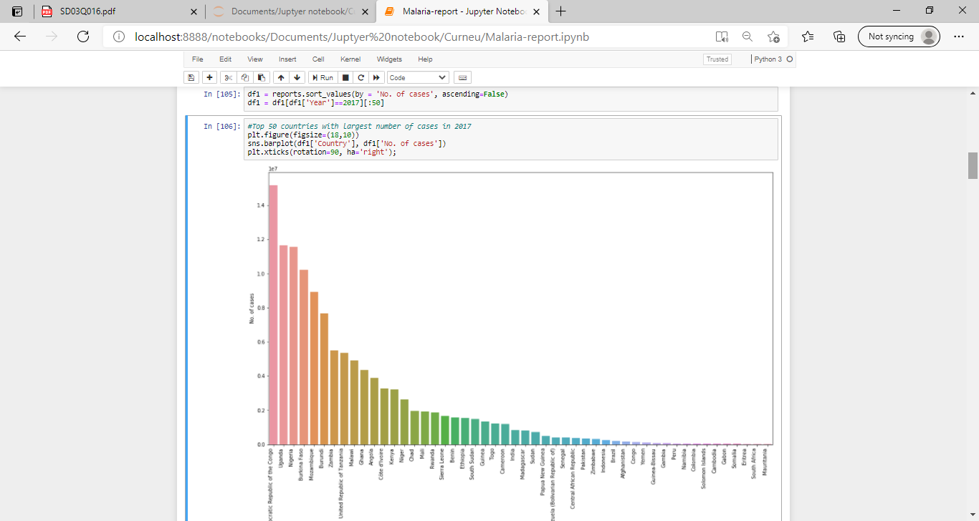

RELATIONSHIP BETWEEN NUMBER OF CASES AND NUMBER OF DEATHS :

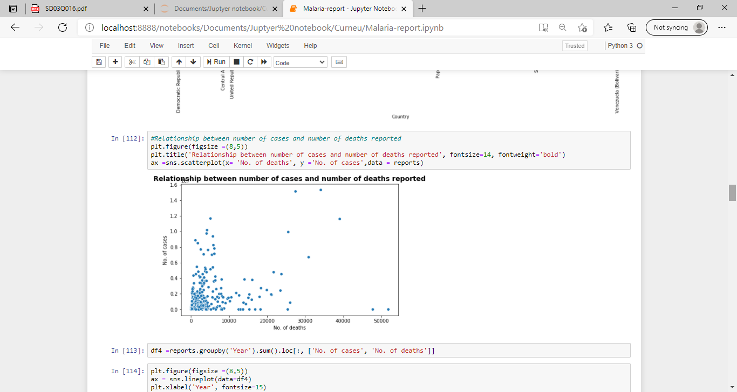

OVERVIEW OF MALARIA DEATH AND CASES OVER THE YEARS 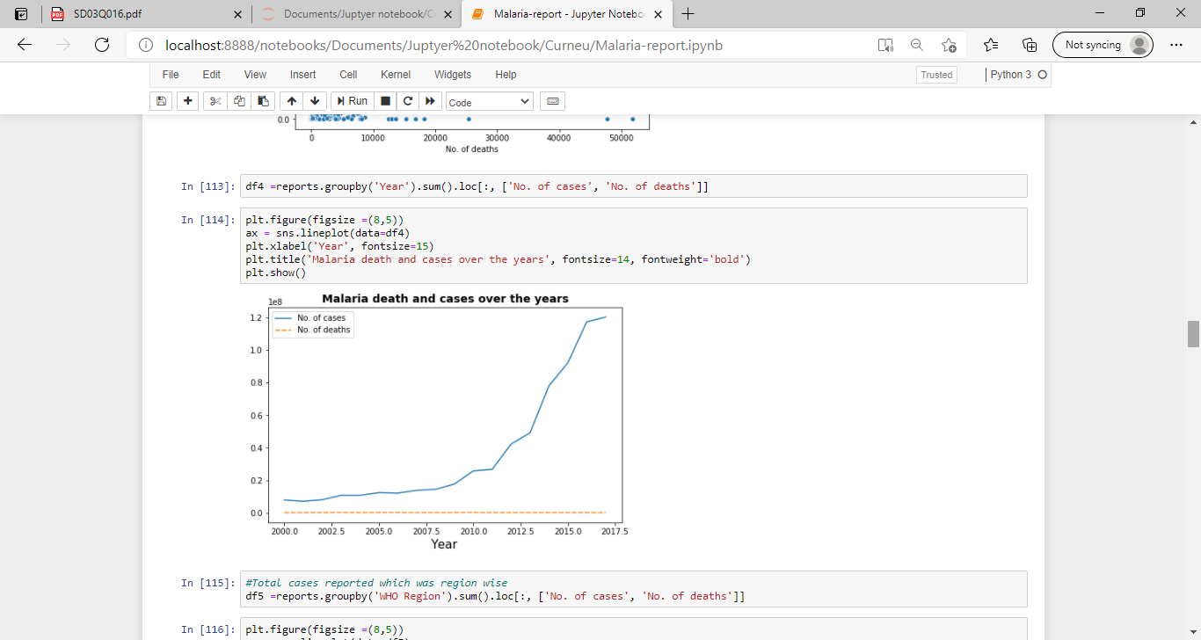

VISUALIZATION USING HEAP MAP :

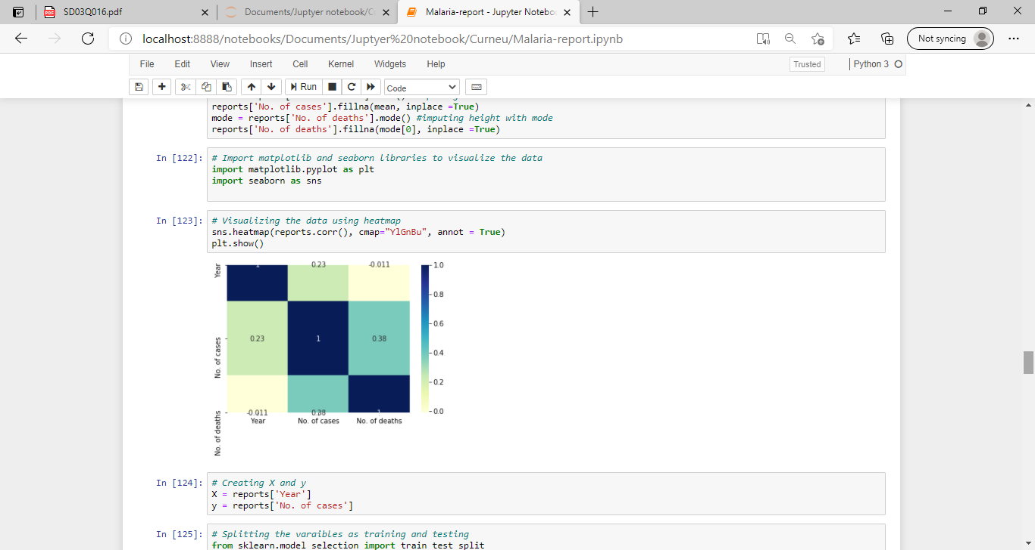

SPLITING TRAINING AND TESTING DATA : 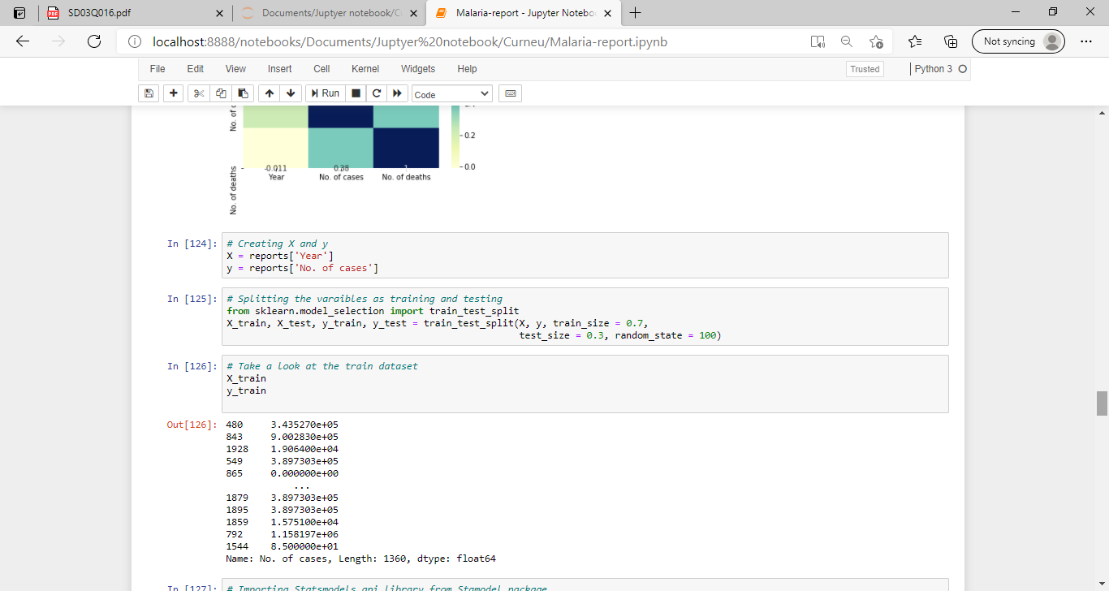

OVERVIEW OF SUMMARY :

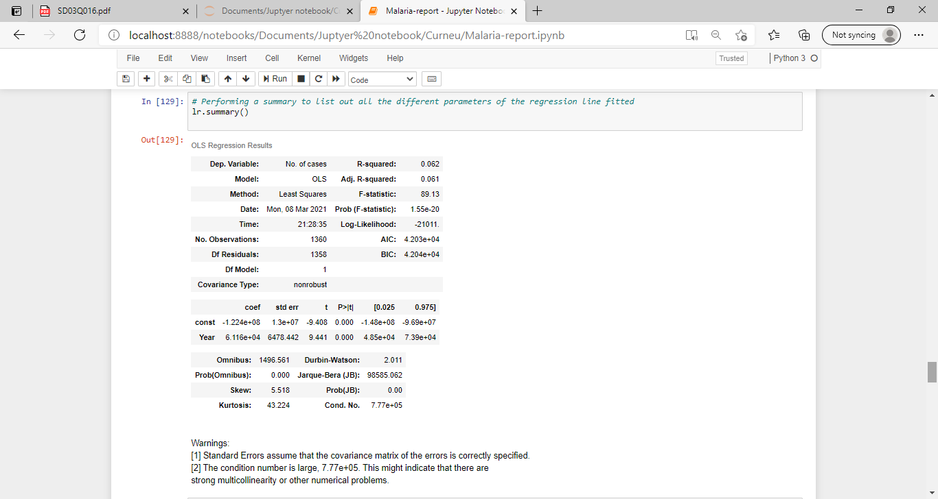

VISUALIZATION OF REGRESSION LINE :

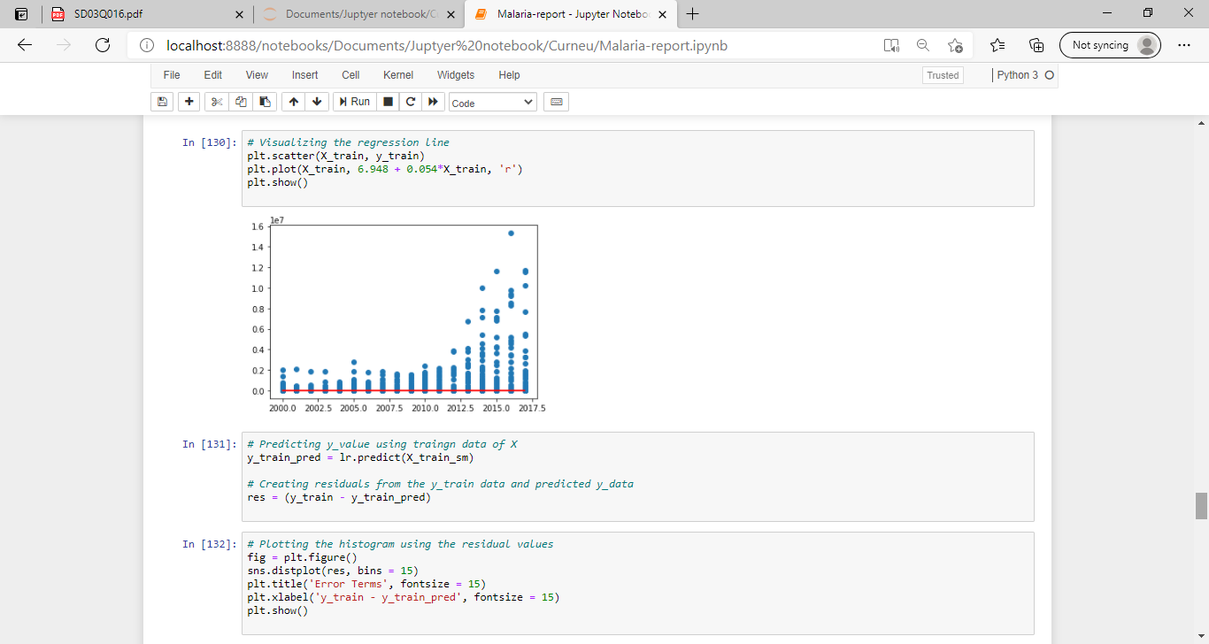

FITTING REGRESSION LINE AND MAKING PREDICTION :

